Discovering the Clean Core Concept

Objective
After completing this lesson, you will be able to describe Clean Core.
Clean Core Overview
To adapt to individual customer needs, the ERP solutions were adapted to a certain extent to fit the business need. This was realized through developments, which allowed customization and could be realized decoupled from SAP. Over the years, the freedom of development led to more effort during upgrades, more maintenance due to required adaptations to the existing development, when changes to the software impacted the custom code. Hence, the freedom of extending introduced disadvantages that led to increased cost. Extensive development is a driver for multiple things, for example, an increased upgrade effort. It also introduces extra maintenance effort to adjust developments and increases the risk of reduced innovation consumption due to custom solution. These disadvantages can be reduced through focus on a clean core, which has a fundament to avoid known custom extension concepts and to adhere to new extensibility concepts.
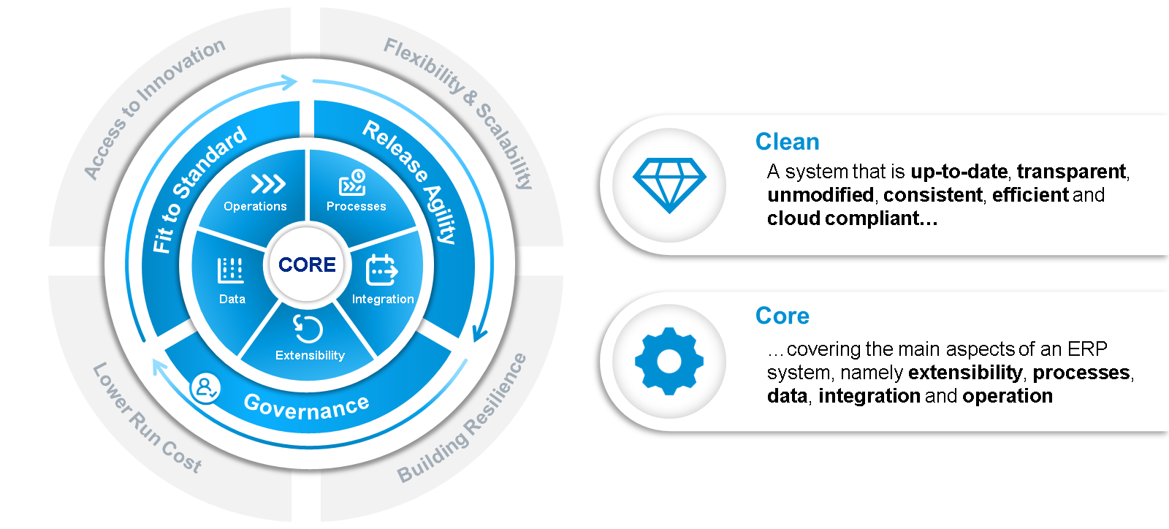
Clean core paradigm is the enabler for competitive, future-ready business; supporting companies to become innovative, agile, and stay relevant through cloud transformation. Clean core is a mind set and philosophy supported with governance and guidelines that lays a foundation for a flexible future proof solution. It considers a modern approach to extend functionality in a stable, upgrade-safe and transparent manner. Introducing to innovate for additional differentiation with the freedom of extending solutions through modern extension approaches as Side-by-Side extension or Microservices, which allow extensibility through multiple platforms spanning from SAP Business Technology Platform (SAP BTP) over Amazon Web Services (AWS) or Google Cloud (GC) beside others.
A clean core allows faster software deployment as well as easier adoption of both. SAP innovations and the regulatory changes to software. It provides new ways to address business needs while avoiding technical debt, thus preparing organizations to maximize strategic benefits and limit cost of transformation.
It drives the adoption and consumption of SAP BTP as the "Platform of Choice" for innovation and development. It reinforces RISE with SAP as the catalyst for starting a Business Transformation Journey.
Clean core spans over multiple dimensions. Software Stack & Core, Process, Integration, Extensibility, Data, and Operations.
Processes, that adhere to clean core leverage Best Practice, reduce variants to the bare minimum and are well documented.
How to achieve a clean core in the dimension of integration? By using SAP standard integration scenarios as exposed in the SAP Business Accelerator Hub, that leverage modern technologies as ODATA, SOAP or Events.
Clean core in the context of Extensibility means that customer extensions are upgrade stable and that custom code and enhancements follow SAP’s extensibility Mode, for example, SAP S/4HANA Cloud Extensibility.
Data must be set up completely, hence incomplete data should be avoided. The same is true for corrupted and unused data.
Addressing a clean core is an ongoing strategic activity. Operations applies the clean core principles, embedding a governance model that considers cloud quality criteria in the End-to-End-lifecycle.
Clean Core: Dimension Details
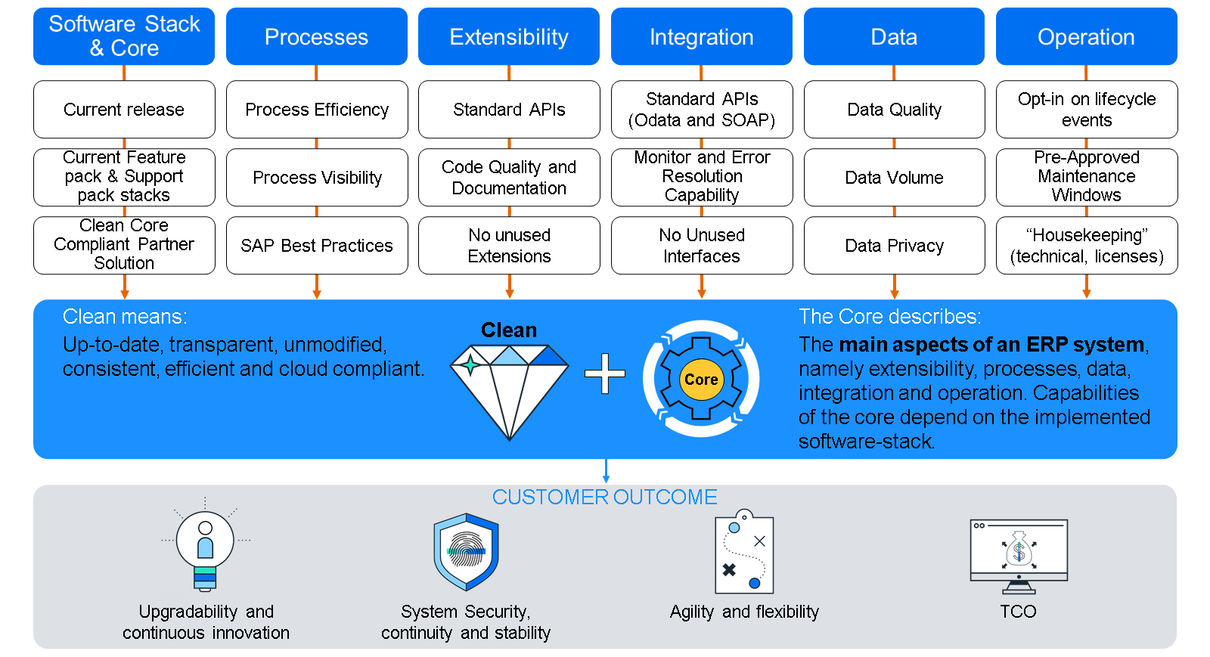
Keep Software Stack & Core current adhering to the respective release strategy.
When looking at Processes the focus is to cultivate a standard first mind set.
To strive for process efficiency considering industry specific variants and to ensure no inconsistent nor inefficient processes are implemented. As well as to apply SAP Best Practices where available and applicable. Gain more insights through Process visibility.
Extensibility Develop new extension and redesign existing code according to ‘clean extension’ rules and based on the new extensibility technologies described in the SAP Application Extensibility Methodology (AEM).
Leverage integrations where possible based on standard API’s, considering proper monitoring and error resolution capabilities.
Under the Data pillar the measures need to be set in place that ensure complete, correct and compliant data adhering to industry standards and legal regulations.
Operations require focus on Solution Documentation, Test Management, and a well-defined Security concept. For example, not having unused authorizations assigned. Batch job Management to avoid performance impact. And to foster continuous Innovation and improvement.
RISE with SAP Methodology: Foundation for Continuous Clean Core Adherence
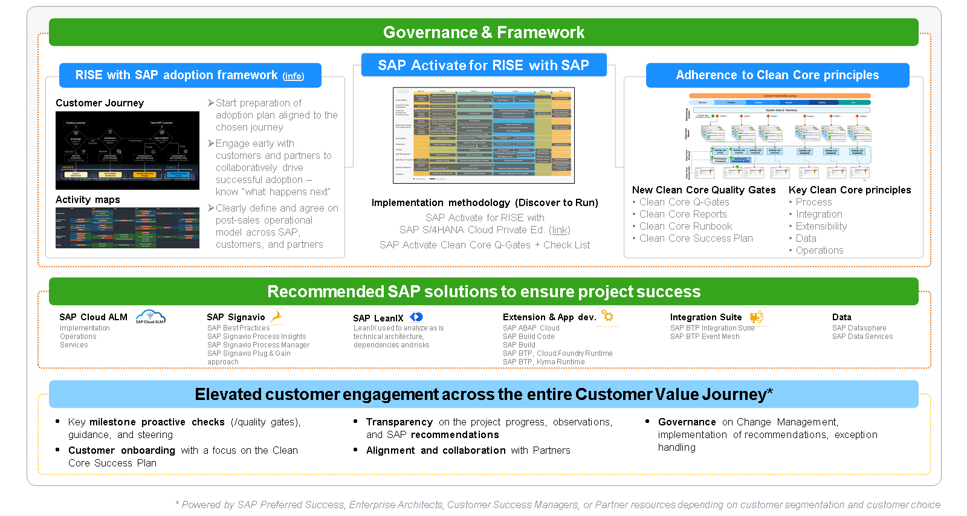
Clean core principles are embedded in Governance & Framework of the RISE with SAP Methodology.
Being anchored with quality gates, it ensures the application of this philosophy in the implementation life cycle.
To find more details for each of the quality gates, follow these links:
- Clean Core Quality Gate 1
- Clean Core Quality Gate 2
- Clean Core Quality Gate 3
- Clean Core Quality Gate 5
Methodology Elements Supporting Clean Core Strategy: System Conversion
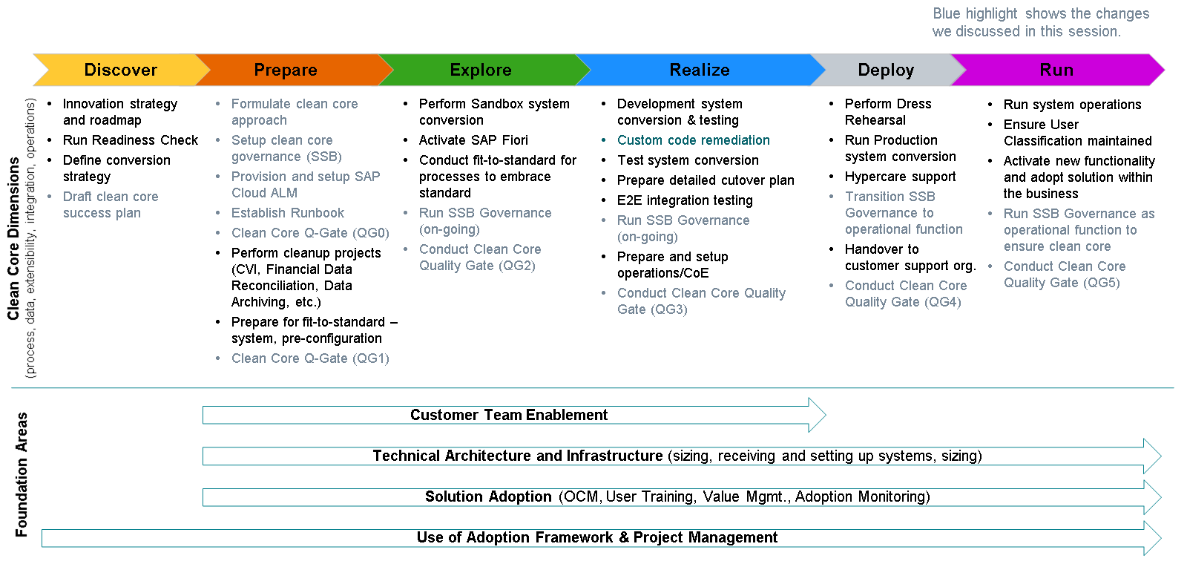
This is an example of select success plan activities with highlights of the new additions to SAP Activate for RISE with SAP related to clean core.
- In Run Establish a continuous ‘keep clean’ process (governance model.)
- SAP Cloud ALM as operations platform. It provides integrated functionalities for monitoring and alerting and supports SAP’s best practice processes for operations.
- Excellent quality of data is one of the key answers to what it means to have a "clean core". However, the impact of bad data quality on various transformational projects, important milestones, such as year-end-closing, and daily business and is-only too often- underestimated.
Further material: Feel free to explore more materials on the blog as well as the learning journey managing clean core for S4HANA Cloud.

